**PART A**

**EXPERIMENT NO. 8**

**A.1 Aim: -** Designing the internal pages of your software

**A.2 Theory**

**PART B**

(PART B: TO BE COMPLETED BY STUDENTS)

*(Students must submit the soft copy as per the following segments within two hours of the practicals. The soft copy must be uploaded on Blackboard LMS or emailed to the concerned Lab in charge Faculties at the end of practical; in case Blackboard is not accessible)*

|  |  |
| --- | --- |
| Roll No: A016 A038 | Name: Varun K, Yashasvi T |
| Class: Btech CsBs 4th Year | Batch: 1 |
| Date of Experiment: 17-02-2023 | Date of Submission: 17-02-2023 |
| Grade: |  |

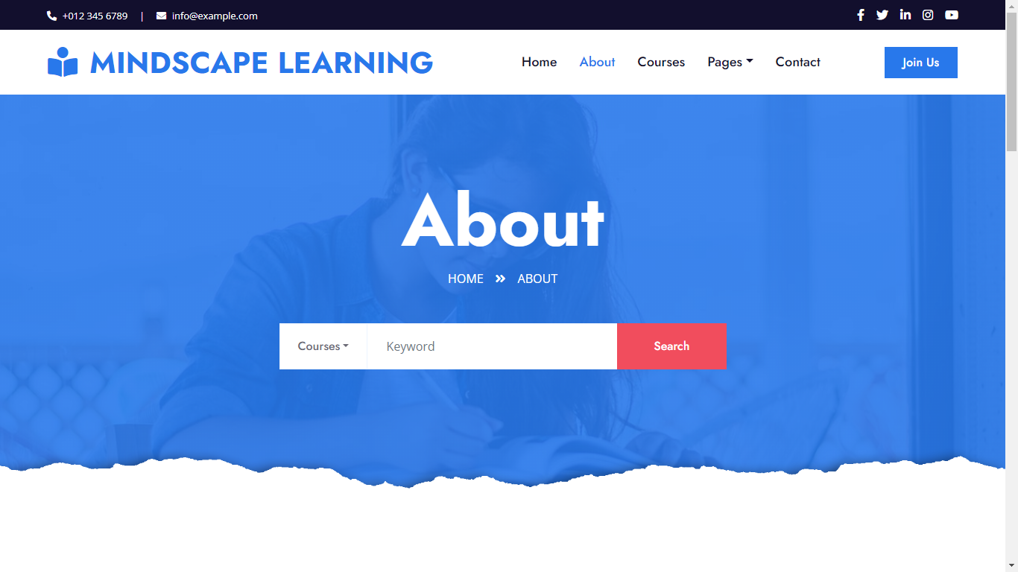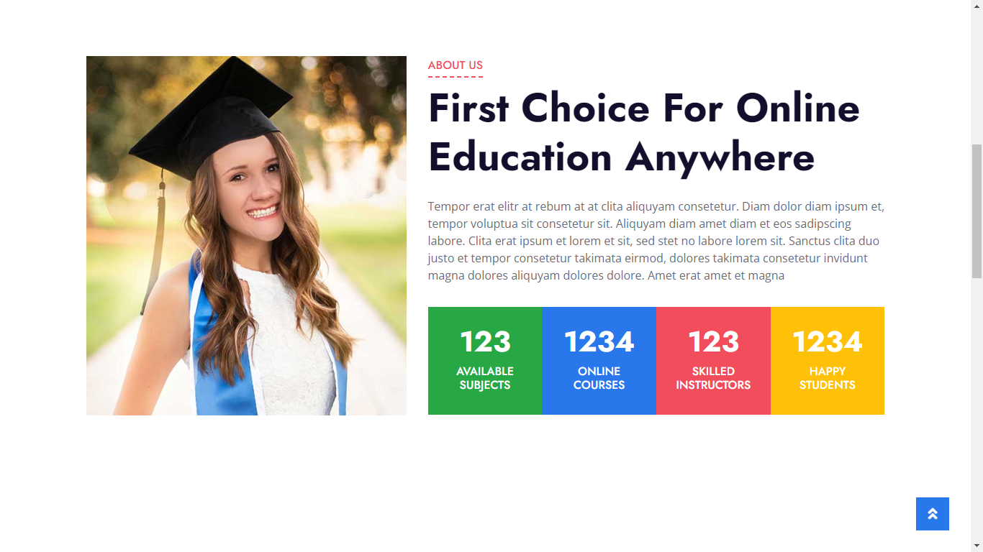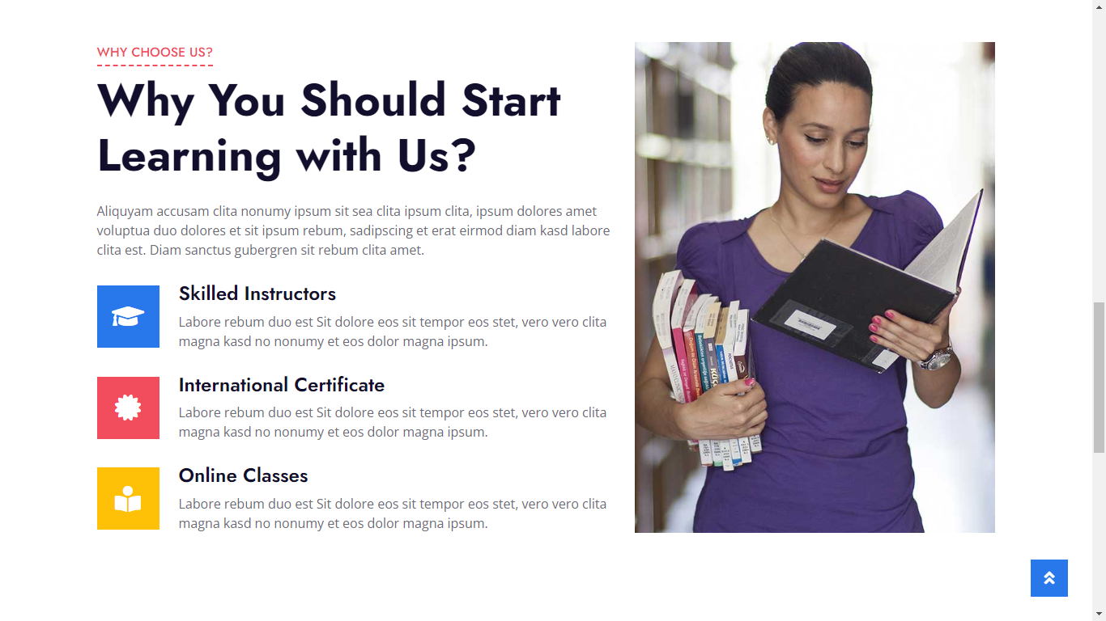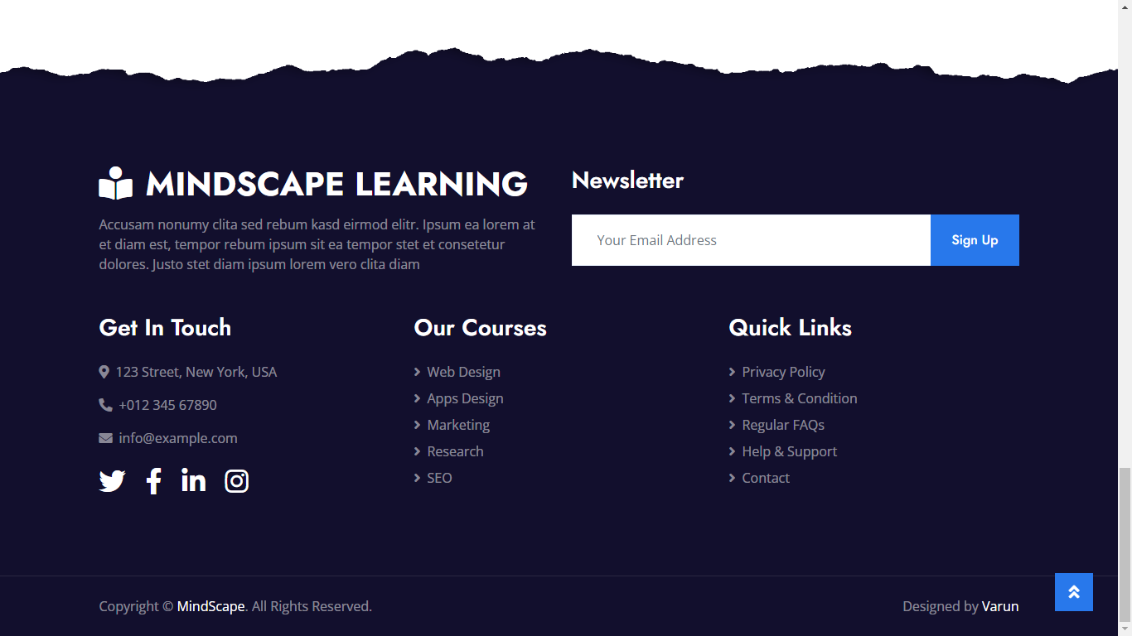

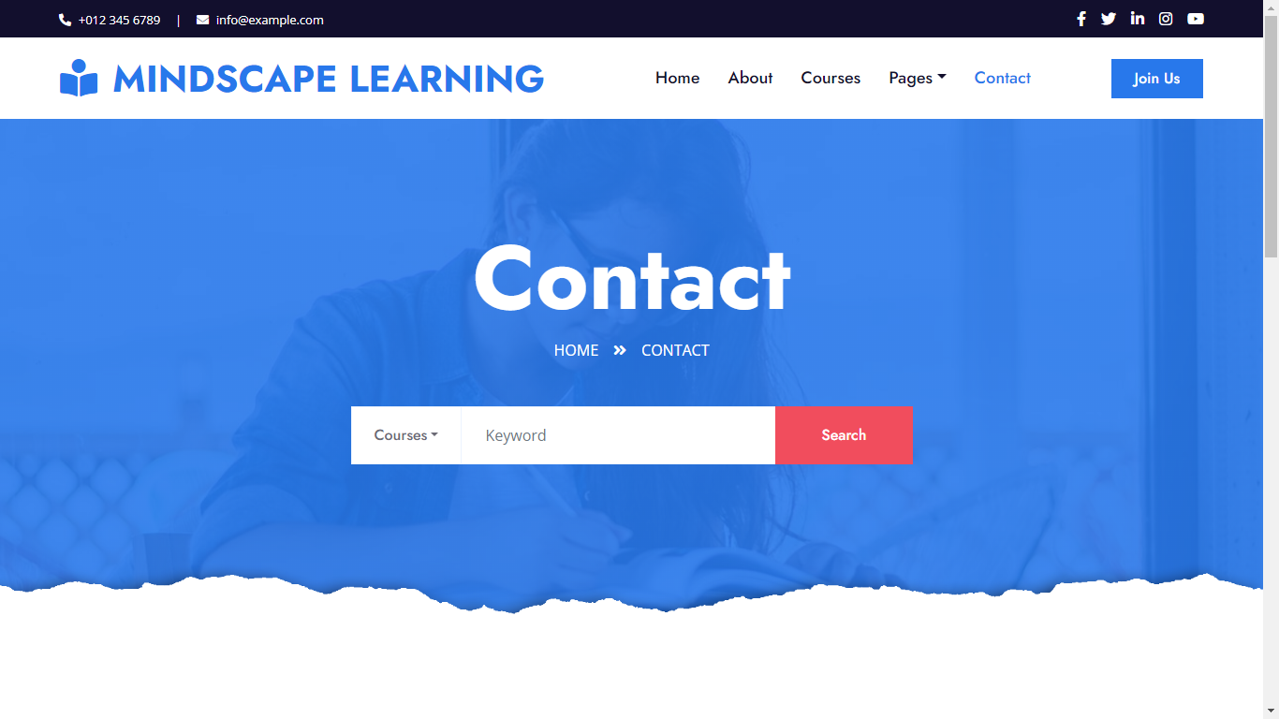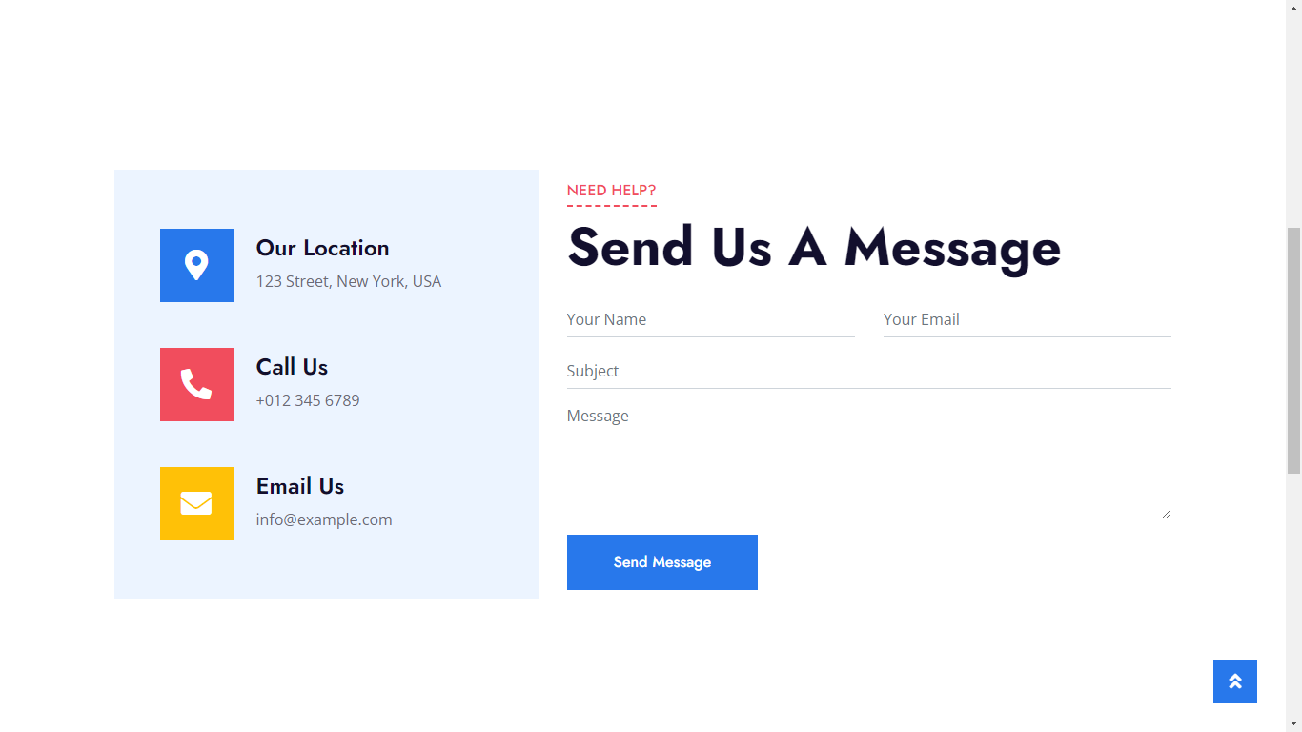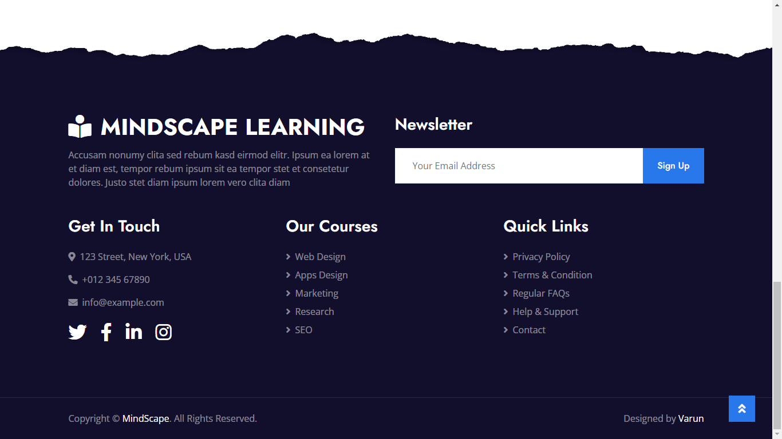

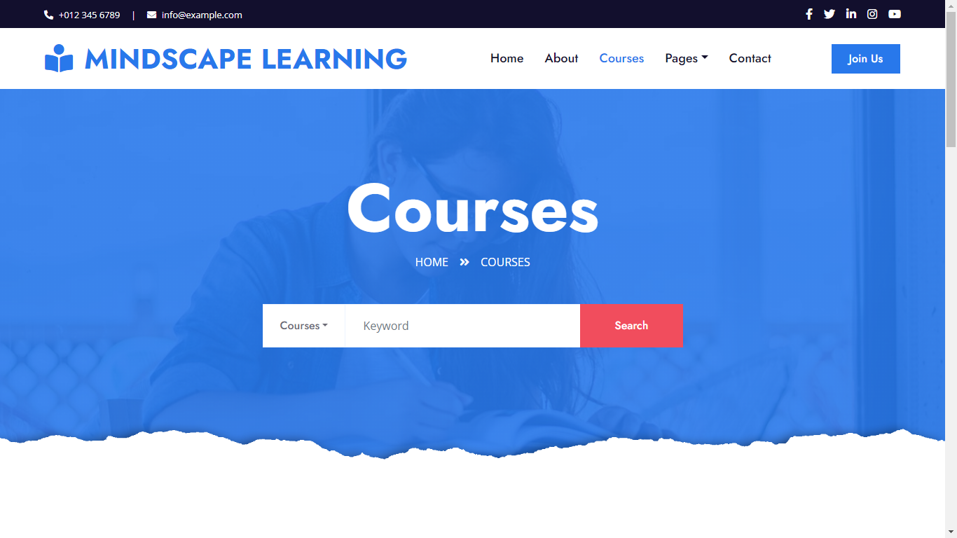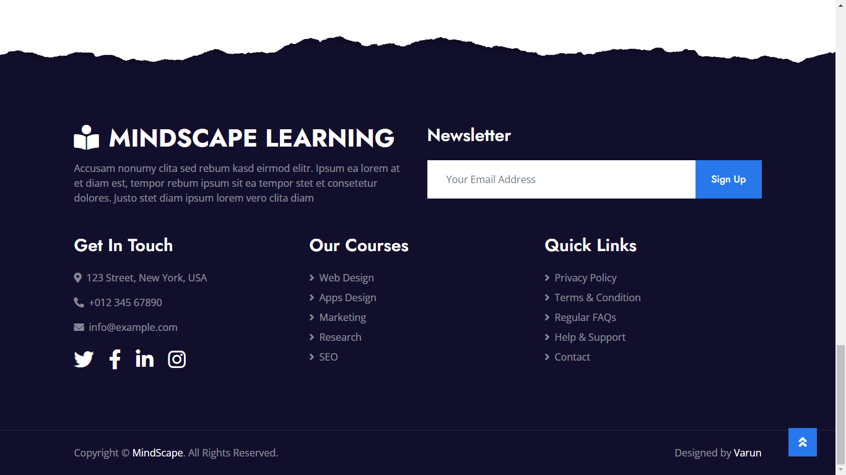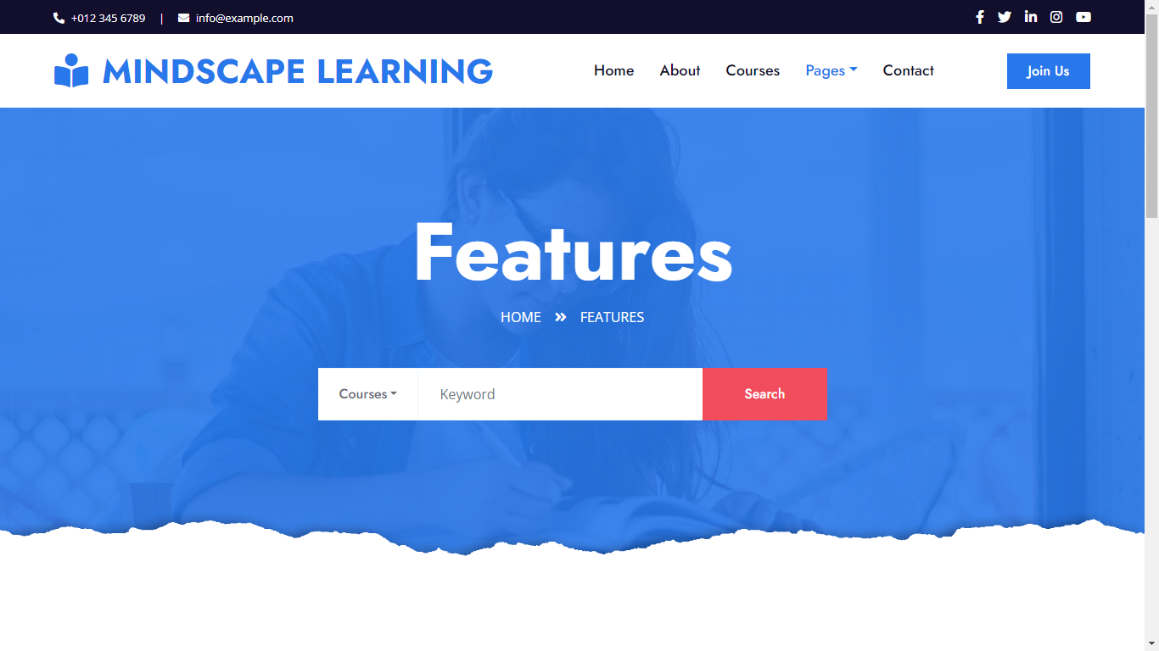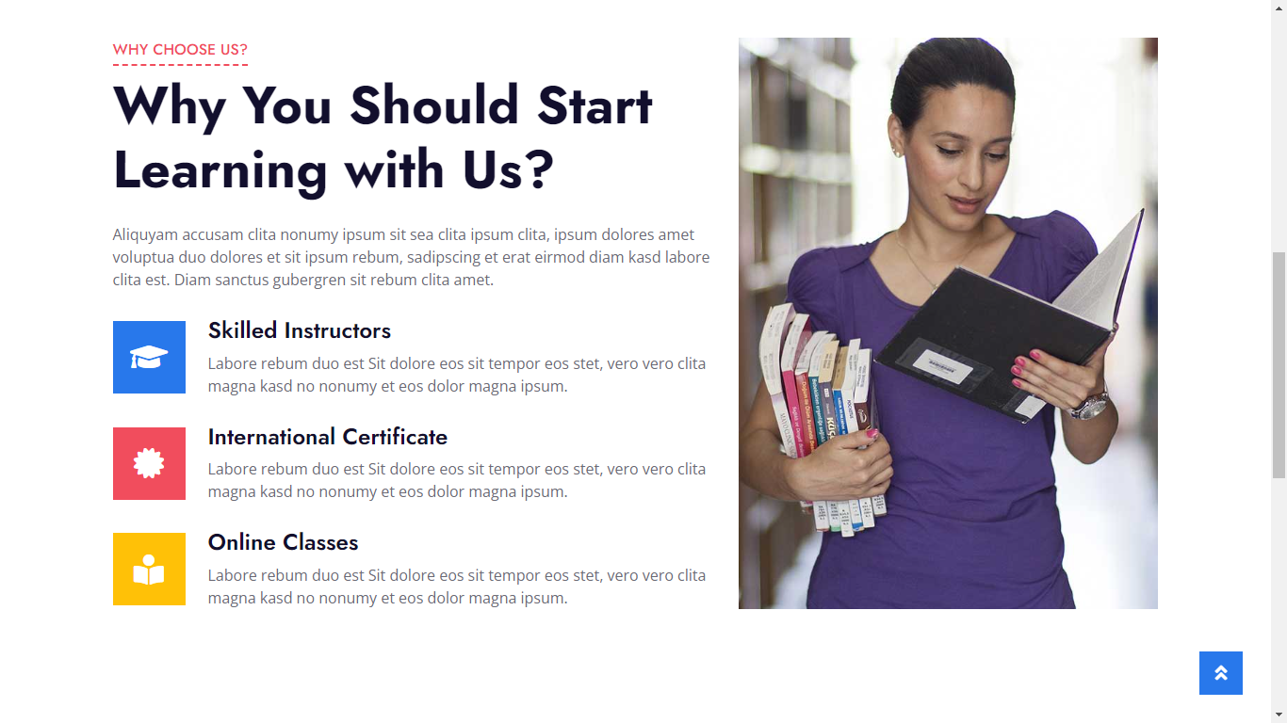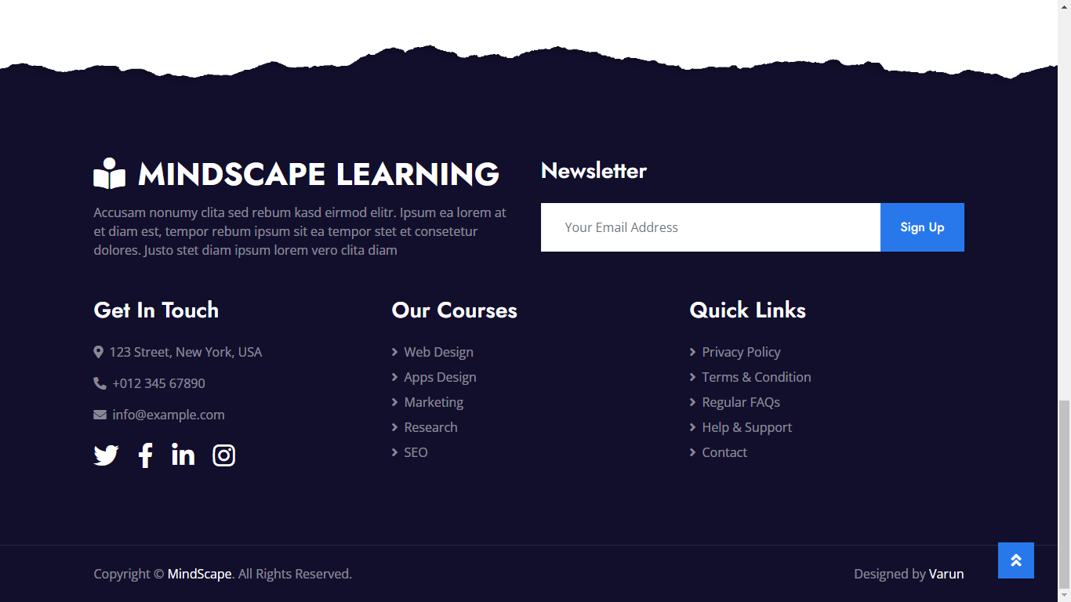

**B.4 Conclusion**

*(Students must write the conclusion as per the attainment of individual outcome listed above and project definition noted in section B.1 including “Define the System, Motivation, Scope of the System and Applications”)*

1. Define the System: The Mindscape Learning website is an online platform that provides educational resources and tools for students, teachers, and parents. The system includes various features such as interactive learning activities, personalized study plans, progress tracking, and gamification to enhance the learning experience.
2. Motivation: The motivation behind the Mindscape Learning website is to provide a comprehensive and engaging platform that empowers students to take control of their learning and helps teachers and parents to support them in their educational journey. The platform aims to make learning more accessible, interactive, and effective.
3. Scope of the System: The scope of the Mindscape Learning website is to offer a range of educational resources and tools for K-12 students. The platform includes various subject areas such as mathematics, science, language arts, and social studies. The system is designed to cater to the different learning styles and abilities of students, from struggling learners to advanced students.
4. Applications: The Mindscape Learning website can be used in various applications, such as:

* Personalized learning for students to track their progress, identify their strengths and weaknesses, and receive feedback on their performance.
* Supplemental resources for teachers to support their classroom instruction, including lesson plans, worksheets, and assessments.
* Parental involvement to monitor their child's progress, provide support, and reinforce learning outside the classroom.
* Homeschooling to provide a comprehensive online curriculum for students who are learning at home.

Overall, the Mindscape Learning website is an edtech solution that provides a comprehensive and engaging platform to support the educational journey of K-12 students, teachers, and parents. It aims to make learning more accessible, interactive, and effective for everyone involved.